INSTRUCTIONS.
- Open the flight case using the 4 catches (2 on each side of the case) as detailed below removing the cabinet lid and placing it to one side.

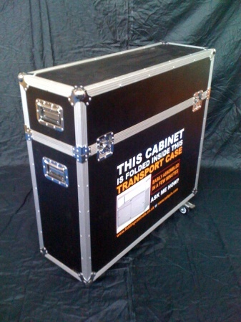 and the close up of the catch 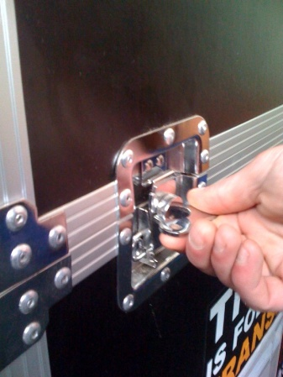
Picture 1 Picture 2

- Remove Panel 1 (Picture 3) from the flight case and unfold Panel 1 which you will clearly see at the bottom of the panel is towards the floor and the glass section is at the top.
You should now end up with a unit which looks like Picture 3 below
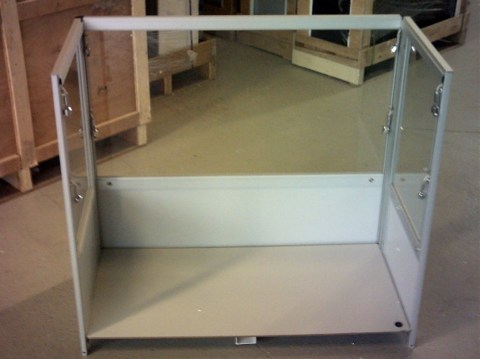
Picture 3
- Now the side panels are open and the power panel is down in place

4 . You are ready to get out the door panel(Picture 9) and slide into Panel 1 side panels of Panel 1(See Picture 10)
Ensure both the glass sliding door and the cupboard is in the locked position before continuing. This will prevent either door from sliding open.
- Locate the large back panel labelled panel 6.. With locks facing outwards of the unit, lift panel 6 (picture 9) This now needs to be located as in picture 10 until it slides right to the floor.

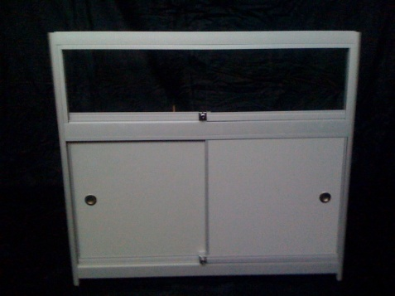 located as follows 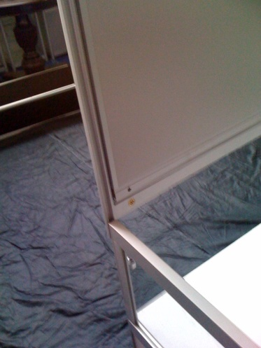 Picture 9 Picture 10

- When you are sliding down the door panel, ensure that you slide down the panel evenly. When you have the door panel almost to the bottom (at least 200mm from floor)
Place foot under the door to steady the power board to be laid correctly on the profile lip (See Picture 11)
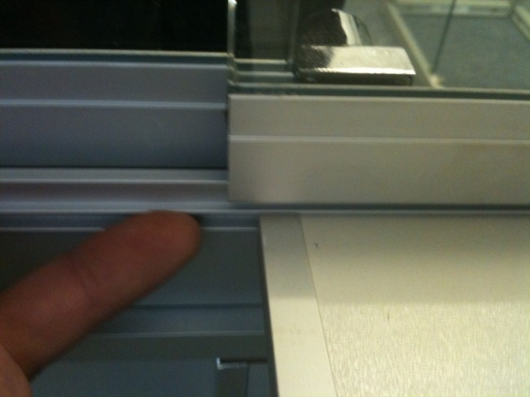
Picture 11

7. Locking panel 6 into position:
Whilst facing the sliding doors of the cabinet you need to look towards the bottom right of the cabinet. Behind each leg you will notice small screw on the outside of the cabinet as shown in picture 12. Ensure the top of the unit is flush (picture 13) before tightening the locking screw

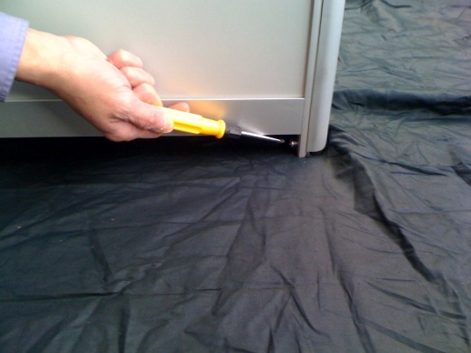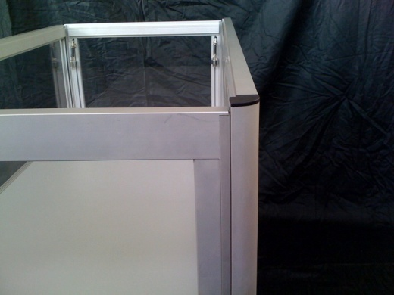
Picture 12 Picture 13

- You will firstly need to unlock the cabinet doors using the keys inside the transport case. The pictures show an FCT-3 cabinet but the same principle applies for an FCT-2 but the picture allows you to be able to view the panels on the photograph through the side glass panel.

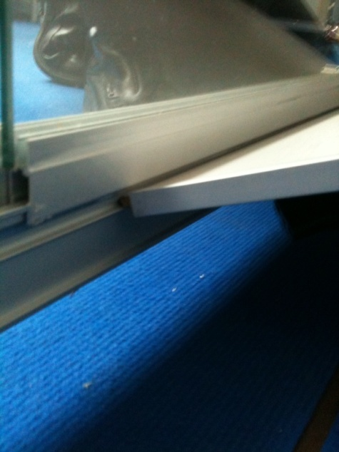
Picture 14 showing locator ledge
The above picture shows where the power board is to locate this onto the ledge as shown in picture 14. Once you have it located you can the slide it towards the left until it is sitting squarely on 3 ledges and the middle of cabinet now have an aluminium strip running from the front to the back of the unit. Repeat this process with the panel that has the handle and it slots in next to the first panel you inserted. This should then locate into the same groove as you located the first panel and then dropping it down so that it lines up next to other panel as in Picture 17
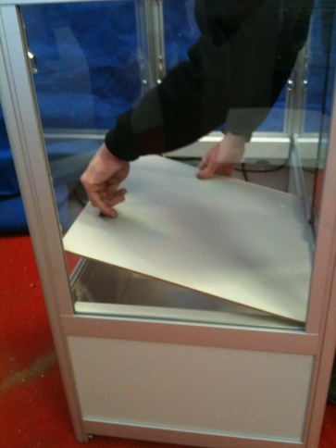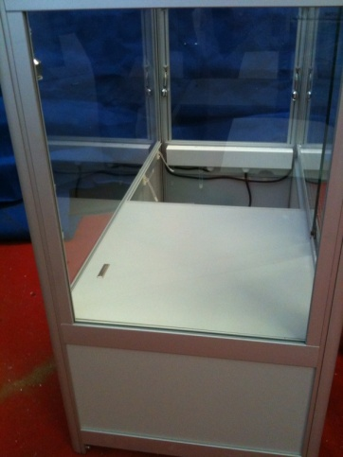
Picture 15 Picture 16
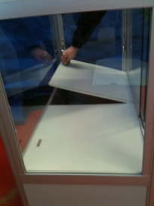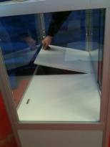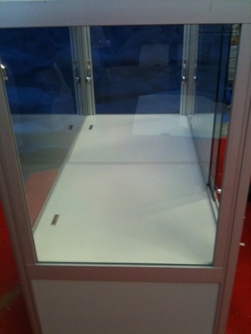
Picture 17 Picture 18 Picture 19

- Inserting the glass shelf
There are 2 glass sections in the flight case; one of which is slightly narrower than the other. It is the narrower of the 2 you will need as this forms the shelf for your cabinet

Start by holding the glass shelf along its length and through the open top of the counter place it at an angle as in picture 24 and 25. Once here you will need to put your hands through the sliding glass doors to manoeuvre it onto the brackets as in pictures 26 and 27
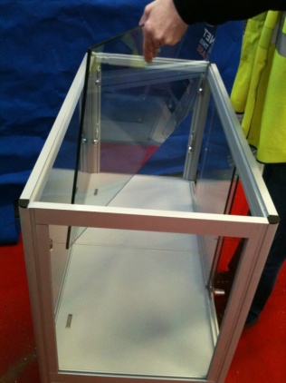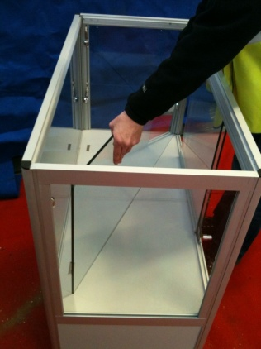
Picture 24 Picture 25
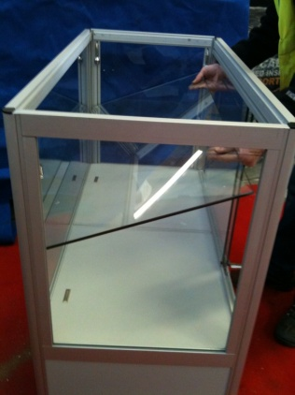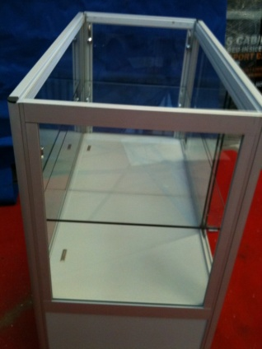
Picture 26 Picture 27
Insert the bulbs into their light fittings before placing the glass on top
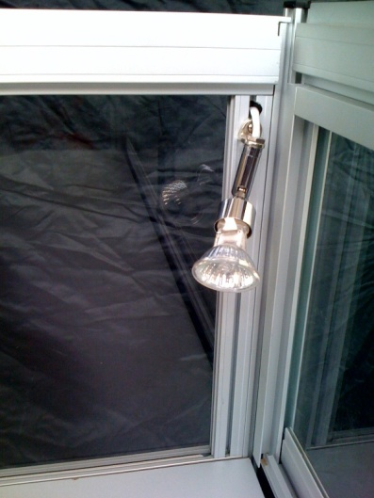
Picture 18
- Finally you need to place the glass onto the top of the cabinet shown in pictures 19 and 20 making sure you have unlocked the glass sliding door before attempting this.
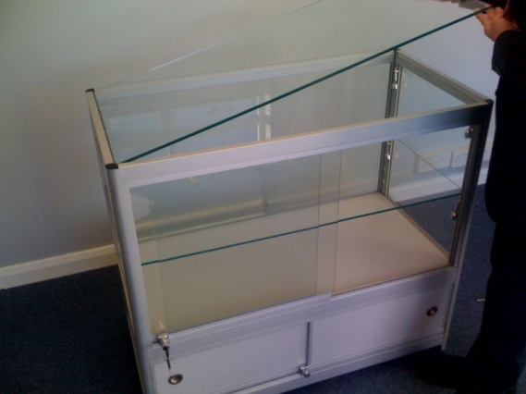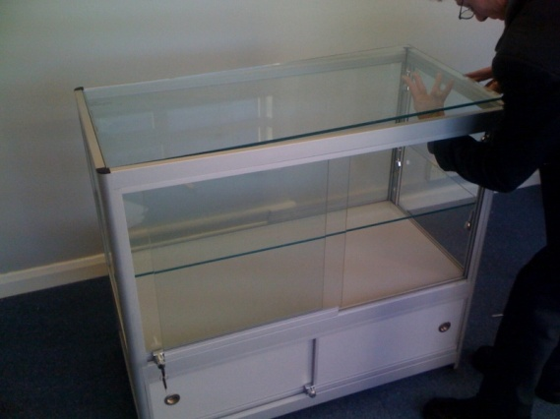
Picture 19` Picture 20
And it should end up looking like the picture below

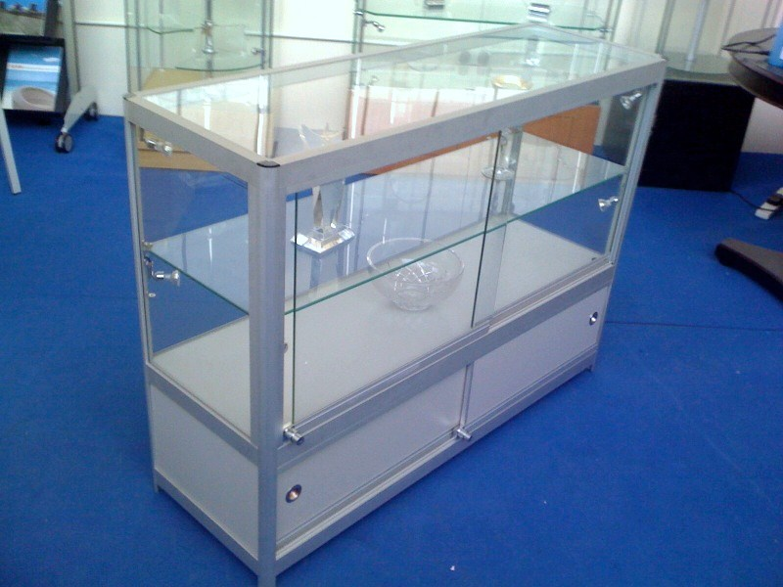

- Finally you need to place the glass onto the top of the cabinet shown in pictures 14 and making sure you have unlocked the glass sliding door before attempting this. Then take the kettle plug lead from the enclosed bag and insert the plug into the power connection on the underneath of the power board.

